DeHaan et al. Supplement A1
Our collection from Honey Creek included 19 individuals from Snyder Creek (a tributary to Honey Creek; see Figure 1). We were unsure if Honey and Snyder creeks represented a single population or if each tributary contained a genetically distinct spawning population. We initially grouped these individuals into a single population and then tested the population for conformance to Hardy-Weinberg equilibrium (HWE) expectations and for evidence of linkage disequilibrium (LD) using the program GENEPOP v4.1 (Raymond and Rousset 1995). We adjusted significance values for HWE and LD tests using a sequential Bonferroni adjustment (Rice 1989). The collection had one locus (Xte23) that deviated from HWE due to an excess of heterozygotes and it showed evidence of linkage at eight pairs of loci. Deviations from HWE expectations and linkage equilibrium can result when individuals from multiple populations are pooled into a single group for analysis (i.e. Wahlund effect). We then grouped fish from Snyder Creek separately from Honey Creek in order to determine if these two tributaries represented distinct populations. We conducted a multidimensional factorial correspondence analysis (FCA) using the program GENETIX (Belkhir et al. 2004) to get a preliminary idea of the relationship among the two tributaries. This method makes no a priori assumptions about an individual’s population of origin and provides an unbiased graphical approach for viewing the data where individuals that are more genetically similar cluster together on the graph. We also used the program STRUCTURE (Pritchard et al. 2000) to determine the most likely number of populations (K) from one to four. We conducted ten replicate STRUCTURE runs with 150,000 burn-in replicates and 200,000 data collection replicates. We used the method of Evanno et al. (2005) to determine the most likely number of populations. Finally, we used GENEPOP to conduct chi-squared contingency tests to determine if there were significant differences in allele frequencies between the two tributaries. The FCA plot (Supplemental Figure A1.1) and the STRUCTURE analysis (Supplemental Figure A1.2) both suggested that the fish from Snyder Creek represented a genetically independent population (ΔK = 2). Furthermore, chi-squared contingency tests showed that there were significant differences in allele frequencies between the two collections at 14 of 16 loci. Based on these results, we concluded that Honey and Snyder creeks likely represent separate populations so these tributaries were analyzed as separate populations for this manuscript.

References
Belkhir, K., Borsa, P., Chikhi, L., Raufaste, N. & Bonhomme, F. 2004. GENETIX v4.05 for Windows.
Evanno, G., Regnaut, S. & Goudet, J. 2005. Detecting the number of clusters of individuals using the software STRUCTURE: a simulation study. Molecular Ecology 14: 2611-2620.
Pritchard, J.K., Stephens, M. & Donnelly, P. 2000. Inference of population structure using multilocus genotype data. Genetics 155: 945-959.
Raymond, M. & Rousset, F. 1995. GENEPOP (Version-1.2) - Population-genetics software for exact tests and ecumenicism. Journal of Heredity 86: 248-249.
Rice, W.R. 1989. Analyzing tables of statistical tests. Evolution 43: 223-225.

Supplemental Figure A1.1. Correspondence analysis (FCA) of Warner suckers collected in Honey (blue diamonds) and Snyder (red squares) creeks.

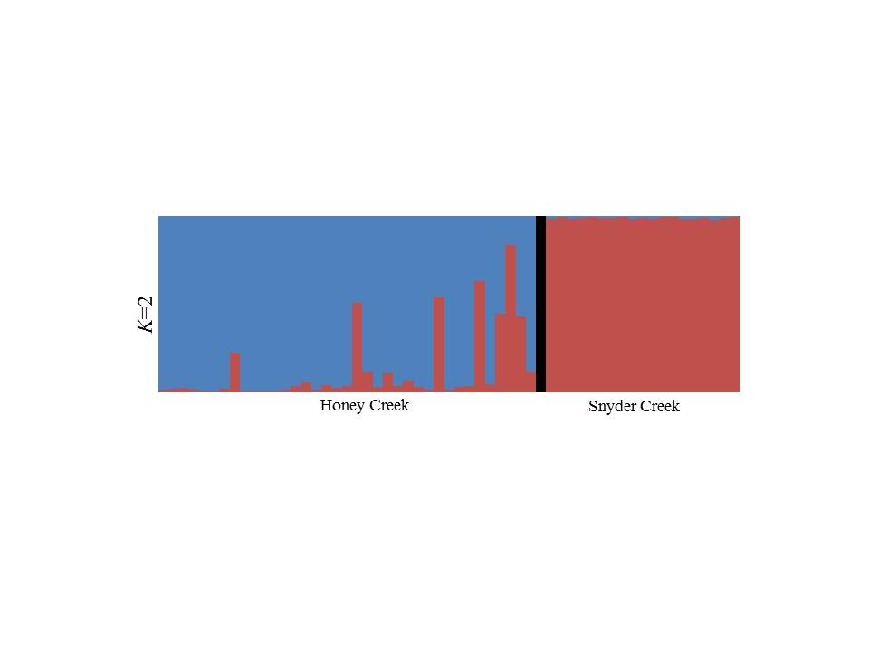
Supplemental Figure A1.2 Output from the program STRUCTURE for Warner suckers collected in Honey and Snyder creek. Output for K = 2 populations (highest delta K) is shown. Each vertical bar on the graph represents an individual in the analysis and the shading corresponds to the porportional membership in each genetic cluster (population).
DeHaan et al. Supplement A2.
We collected temporal replicate samples from three of the five tributary populations in this study: Snyder Creek, Twentymile Creek and Summer Lake WMA irrigation canal. We wished to test for significant allele frequency differeces among temporal replicates from these tributaries before combining samples for statistical analysis. We did not conduct a temporal comparison of the samples from Snyder Creek because of the low sample size in the 2012 sample (n = 3). For Twentymile Creek and Summer Lake WMA, we split temporal replicate samples into collections according to sample years. This resulted in four temporal collections for Twentymile Creek (2007, 2008, 2009, 2010) and two temporal collections for Summer Lake WMA (2007 and 2009). We used GENEPOP v4.1 (Raymond and Rousset 1995) to estimate the pairwise level of genetic variation among temporal replicates from each tributary (i.e., pairwise F_{ST}) and to conduct contingency tests of allele frequency heterogeneity among temporal replicates. Significance values for allele frequency heterogeneity tests were adjusted for multiple comparisons using a Bonferroni adjustment.
Pairwise F_{ST} estimates for the temporal replicates from Twentymile Creek ranged from 0.002 to 0.022 and the number of loci that exhibited significant allele frequency differences ranged from zero to two (Supplemental Table A2.1). Because the temporal replicates from Twentymile Creek showed very low levels of pairwise variation and only limited differences in allele frequencies among replicates, we combined temporal replicates from this population for subsequent statistical analysis. For the Summer Lake WMA population, the pairwise F_{ST} estimate between the two temporal replicates was 0.025 and 10 of 16 loci showed significant allele frequency differences. Although we did observe some evidence of temporal structuring among collections from the Summer Lake WMA population, the level of pairwise variation was substantially less than what we observed among natural tributary populations. Because of this, and the fact that Summer Lake WMA is an isolated, refugial population, we chose to pool temporal replicates from this tributary into a single population for analysis. Waples (1989) recommended this approach as the most accurate means to estimate allele frequencies for species with overlapping generations.

References
Raymond, M. & Rousset, F. 1995. GENEPOP (Version-1.2) - Population-genetics software for exact tests and ecumenicism. Journal of Heredity 86: 248-249.
Waples, R. S. 1989. Temporal variation in allele frequencies: testing the right hypothesis. Evolution 43(6):1236-1251.

Supplemental Table A2.1. Genetic variation among temporal replicate samples from Twentymile Creek. Values below the diagonal represent pairwise F_{ST} values and values above the diagonal represent the number of loci (out of 16) that showed significant allele frequency differences among collections.
 | 2007 | 2008 | 2009 | 2010
2007 | --- | 1 | 0 | 0
2008 | 0.014 | --- | 2 | 0
2009 | 0.019 | 0.022 | --- | 0
2010 | 0.002 | 0.010 | 0.011 | ---

DeHaan et al. Supplement A3.
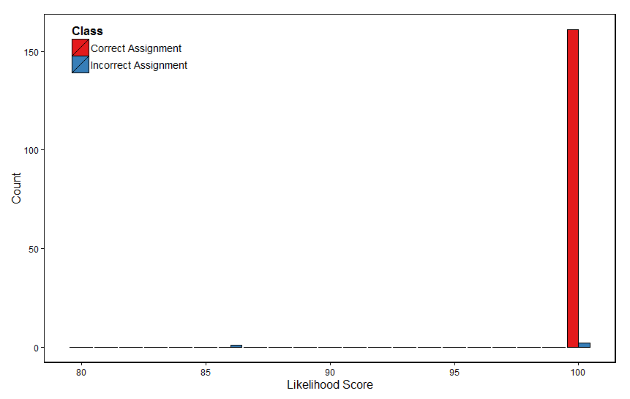
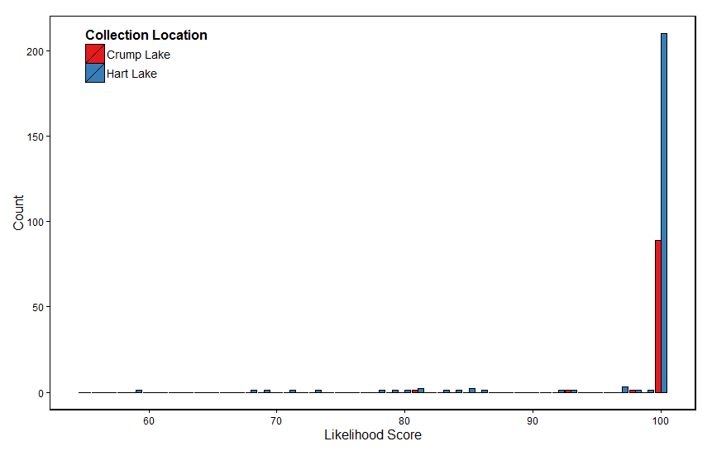
Distribution of likelihood scores for genetic population assignments. The top graph shows the distribution of likelihood scores for leave-one-out assignment tests of the baseline dataset. Red bars correspond to likelihood scores for individuals assigned to the population they were collected from (i.e., “Correct Assignment”) and blue bars correspond to individuals assigned to a population that they were not collected from (i.e., “Incorrect Assignments”). The bottom graph represents the distribution of likelihood scores for genetic assignments of unknown origin individuals collected in Crump (red bars) and Hart (blue bars) lakes.

